Dorset Field Trip Report 23-27 March 2015
Sandbach U3A Birdwatchers

Fourteen members left Cheshire on a dry Monday morning, battling traffic on the M6/M5, heading for our first stop at New Fancy in the Forest of Dean. Eyes, shorn of sleep, were already turning outboard from the cars, picking up a Red Kite en route. As a raptor hotspot, New Fancy didn't meet expectations, as overcast near windless conditions kept the raptors out of the sky. Still it was good to be in a different landscape, and a pair of Raven overhead, and a pair of Bullfinches through the trees, held our attention.

We moved on to nearby Cannop Ponds and we were soon gazing at the fantastic plumage of the male Mandarin Duck, five pairs in total being present. The females too were very smart in their demure soft grey, donkey brown and white plumage. Green Woodpeckers yaffled before one was spotted in undulating flight through the picnic area. A Grey Wagtail was found on a stream between two of the ponds, and Willow Tit and Goldcrest were spotted too. Our last stop in the Forest was Parkend, where we looked for Hawfinch near the cricket ground. Just one was present, feeding in a tree slightly away from the normal area, and seen by one lucky member.
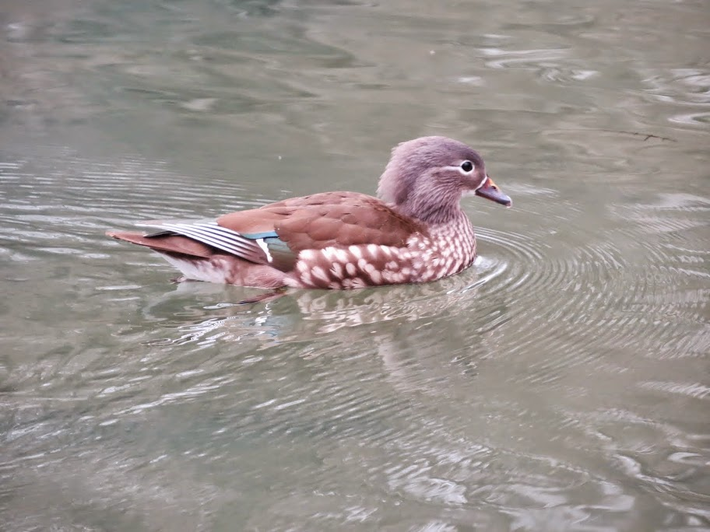Female Mandarin at Cannop Ponds

We drove on towards Portland, arriving there with the rush hour traffic. We made our way up to our hotel, settled in, had dinner, and after the evening log call, "Early night" was writ large upon many faces.

Tuesday dawned clear but with a cold wind, conditions that stayed with us for most of the week. We started on the Bill itself, very soon picking out migrant Wheatears, Meadow Pipits and a Chiffchaff, while being serenaded by a Skylark. The rough ground next to the Bird Observatory was being guarded by a female Stonechat, and we could see movement within the observatory grounds, which is used extensively for ringing. We were very quickly in the grounds and occupying the park benches thoughtfully provided, watching the tooing and froing of the resident tits and finches. The warden then approached, having completed the regular trap round of the garden mist nets, carrying a keep bag. He welcomed us, and like a magician, produced from the bag a Firecrest. The closeness of the bird allowed us to appreciate the subtlety of its plumage, the green of the back shading to russet on the shoulders almost glowing, and the orange crest vivid against the warden's hand.
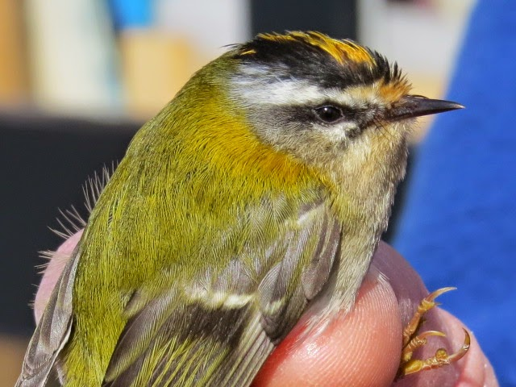Firecrest at the Observatory

Alice wrote of the encounter:- "One of the birding highlights of the trip for me happened on the Tuesday during the visit to the Portland Bird observatory. We had heard that Firecrests had recently arrived but I didn't see one until the warden, having caught it in a bag, showed it to us sitting in his hand. It was tiny - 5 grams in weight - and so pretty with well-defined eye stripe. I had never before seen a wild bird in a person's hand and was amazed that it didn't struggle or seem at all distressed by being handled. We were standing close to it and could see the details of the colouring, the stripes, the individual wing and tail feathers and of course the orange brightness of its crest; then the warden stroked its head and blew on it gently so the crest rose up and we could see the full beauty and depth of the crest feathers. An amazing and unforgettable experience! The warden then moved away, opened his hand and it flew off into a nearby bush." An experience that was the subject of conversation throughout the trip and beyond.

We should mention too the supporting cast of a wintering female Blackcap which came to upturned fruit halves in the feeding area, and another migrant Chiffchaff, sliding through the foliage.
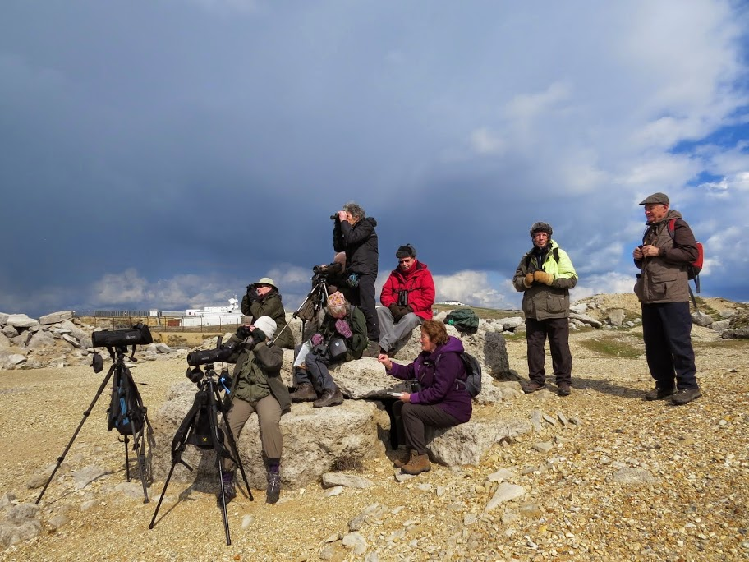 Sea-watching at the Bill
We moved back to the bill itself for some sea-watching, finding some convenient rocks to perch on. Rock Pipits were feeding on the edge of the Bill quarry, and we were soon picking out a couple of Gannets travelling down channel. Shags were rounding the Bill heading for the west side cliffs, and the differences between Shag and Cormorant were discussed. Small groups of Guillemots and Razorbills were sitting on the sea, and speeding past on whirring wings, while a piratical Great Black-backed Gull cruised through.

With migrants few and far between we headed for Abbotsbury, to a roadside vantage point from where we could see, what else, Mute Swans. Scopes were a necessity, and Meadow Pool produced Shoveler, Teal, Wigeon, Gadwall and Shelduck, while Tufted Duck, Pochard and Great Crested Grebe were on the Fleet. Green Woodpecker was heard in a nearby wood, and a Little Egret mixed with the wildfowl.
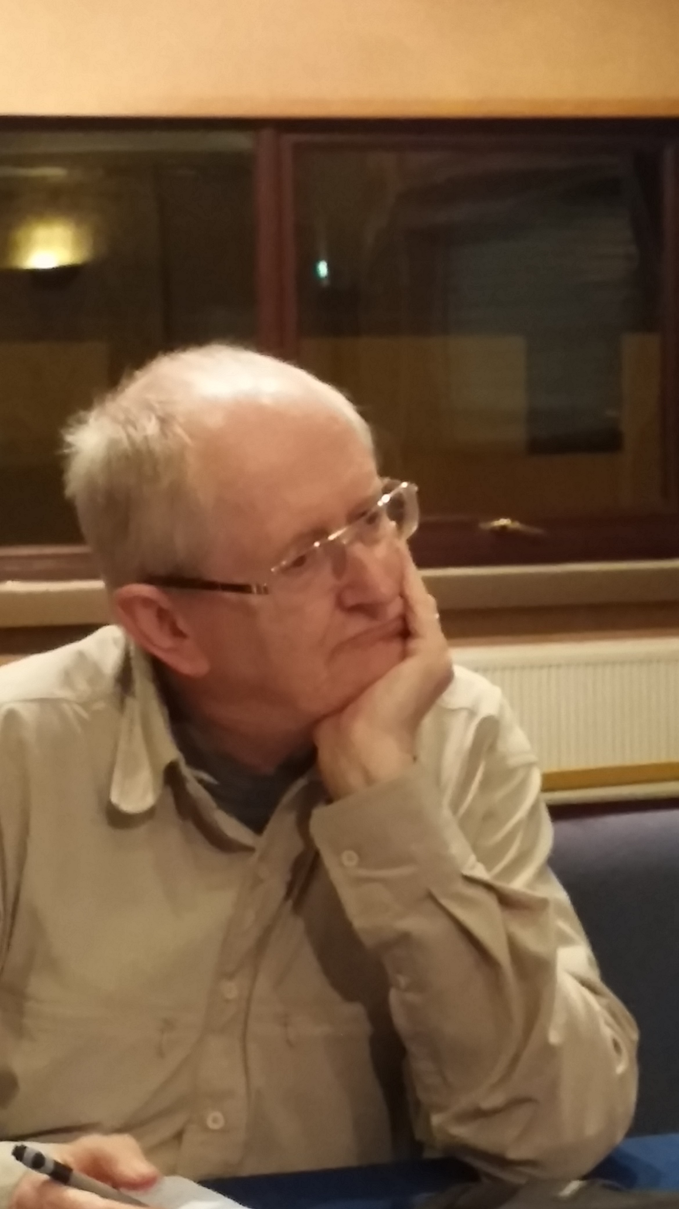
Quiz time
We returned toward Portland, tarrying at Ferrybridge to see if any waders were about. Curlew, Ringed and Grey Plover confirmed that there were, Red-breasted Mergansers gathered by the bridge, and then we drove back up on to Portland. We finished the day at the Observatory Quarry, waiting for the Little Owl to appear. A second Firecrest was glimpsed deep in the brambles, but no owl was seen. A Sparrowhawk tipped over the lip of the quarry to give great views, and we took that as a sign that our birding day had come to an end. Just the first part of Rosamund's quiz left to tantalise our members.

Day 3 saw us on the road early, heading east to Poole Harbour. First stop was Brand's Bay, where a short hike across heathland brought us to the hide overlooking the Bay.
Small parties of Brent Geese fed along the shore, and a male Stonechat "chakked" at us from the top of a bush. Telescopes were the order of the day for the far shore of the bay, where we could see Pintail, Oystercatcher, Black-tailed Godwit, Grey Plover, Curlew, Redshank and a couple of Avocets. Longer legs belonged to Little Egret and Heron, and pairs of Red-breasted Merganser floated in the channels. A brief stop on Studland Bay brought only views of more Mergansers and Great Crested Grebe.
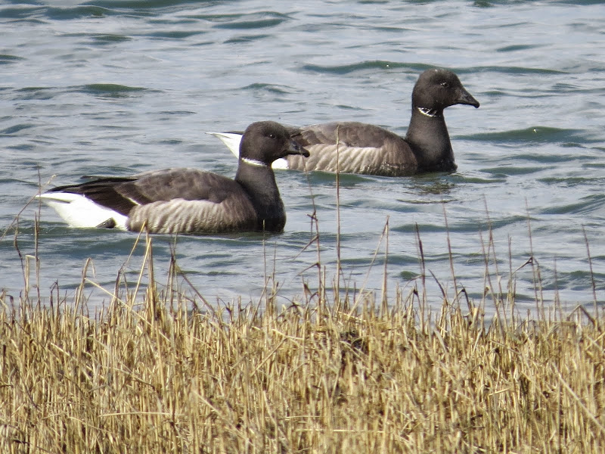Brent Geese - Brand's Bay

Lunch was taken at the "Bankes Arms" in Studland, a known spot for Parakeets. A Peregrine scythed across the sky as we sat down, and must surely have scared any Parakeets, which stayed away. We moved onto Arne, one of the RSPB's flagship reserves. Nuthatches were on feeders behind the cabin while we gathered information on what we were likely to see. We headed off towards the Middlebere Channel, hoping to see Dartford Warbler from the Combe Heath viewpoint. No such luck, but we did spot 9 Spoonbills roosting on a sandy island, one of which decided an overflight would be just the thing - we thought so too, as neck outstretched it flapped overhead.

Alice again: "A second highlight occurred at Arne; we saw a small group of white birds sitting huddled with their backs to us and their necks tucked in. I had to be assured these were spoonbills as I couldn't see any features I recognised!! Then minutes later one took off and was flying - legs, neck and head stretched out and we had a wonderful clear view of the bill with its spoon as it flew past. Another wonderful sight!"

We walked on to the hide overlooking salt marsh pools and sandy islands, where the Spoonbills stood one-legged, cloaked in white wings for their roost. We were able to pick out waders, including both Black- and Bar-tailed Godwits among the Redshank, with a single Dunlin. Our walk back ran across a feeding party that included Siskin, Long-tailed Tits and Goldcrest, while a Green Woodpecker yaffled in the background. The drive back seemed long, and drooping eyelids at the dining table told their own story.

Overnight bad weather rattled the hotel, and we woke the next morning to thick mist, heavy rain and strong winds. We delayed the day's start by an hour, and sure enough the clearance reached in from the west, stripping the overcast away and replacing it with sunshine. We started the day at Portland Castle, noting Shags roosting on a section of Mulberry harbour, 22 Red-breasted Mergansers occupying the near-harbour waters, and a couple of Herons asleep on the marina breakwater. The garden at the Castle yielded another Chiffchaff, and a Kestrel chased prey on the ground around the drains of the former RN headquarters building.

We moved on to RSPB Radipole, where the commoner wildfowl and gulls dotted the waters, along with Cormorants and Herons. The paths between the reeds often hide the stretches of water, but do provide cover for passerines. and it wasn't long before the explosive song of Cetti's Warbler burst out alongside the path. At least three were heard, with one of them seen skulking around a hawthorn tree near the bridge. A couple of Chiffchaffs also moved restlessly along the hawthorn bushes lining the paths. We went on to the hide at the northern end of the reserve, where the first few to arrive saw a Marsh Harrier quartering the reed beds. The hide overlooked scrapes where Black-tailed Godwits were feeding, and a patient search revealed a Wheatear moving through flattened reeds.
Our return to the bridge coincided with the appearance of the renowned Hooded Merganser, which made Radipole its home some years ago.
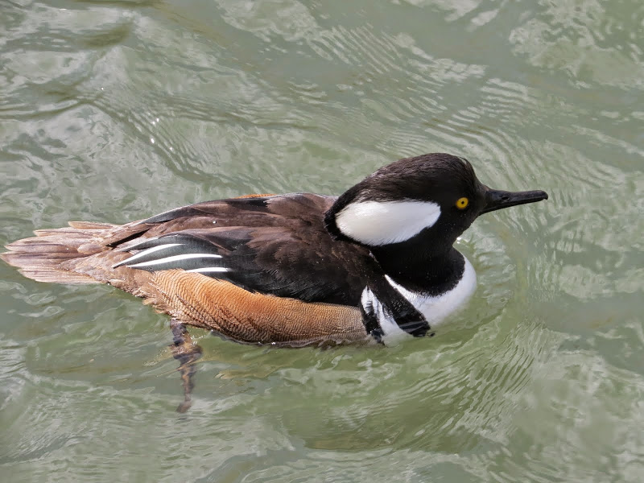Hooded Merganser - Concrete Bridge, Radipole

Lodmoor came next, but we diverted on to the shore to scan Weymouth Bay. One of our missing migrants became a lot less scarce as we picked out a Sandwich Tern tacking across the Bay. A Gannet was spotted, at the limit of 'scope range, and a couple of Mediterranean Gulls battled the strong wind towards Overcombe. Lodmoor itself produced little that was new, although we had only the second male Pochard of the week. Intense study of one of the large gulls among the Herrings and Lesser Black-backeds produced the opinion that it was in fact a Yellow-Legged Gull, sporting a slightly darker mantle than Herring Gulls and yellow legs.

We returned to the Bill, to try and make the owl's acquaintance again. We were treated to Skylark song once more, and a Kestrel hunted around us. And then a series of hoots from deep within the lower quarry wall proclaimed the Little Owl's presence, with the message "And that's all you're getting!" We returned to the hotel, for dinner, and the final part of the quiz, and then "Time for bed" said Zebedee.

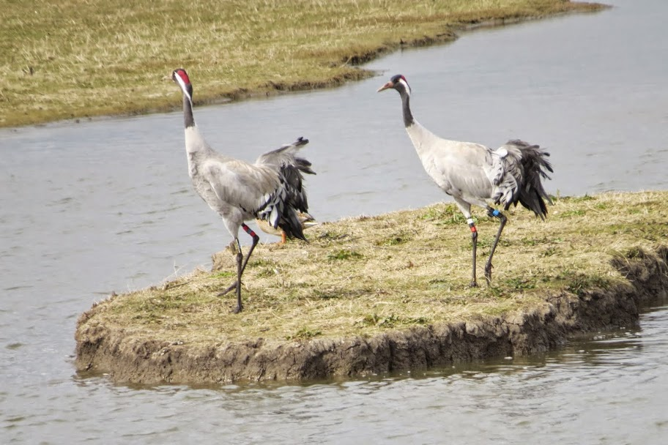
We left Portland the next morning, with three cars bound for Slimbridge on the way home. We arrived in the car park to the bugling of Cranes, and Cranes it was that dominated the visit, seen in the air, on the ground and displaying and calling. The WWT reserve held its usual good numbers of wildfowl and waders, with Pintail and 22 Avocets being the pick of the bunch. A Peregrine sat out on the Dumbles, and Reed Buntings joined the throng at the Willow Hide feeders. And very quickly it was time to mix it with the weekenders flooding north on the motorways, the end of a thoroughly good week's birding. We amassed a total of 101 species for the week. Until next time.

Courting Cranes at Slimbridge

Richard Howells
Comments: Alice Blackburn
Images: Derrick Bradley

DORSET - MARCH 2015 LIST Sandbach U3A Birdwatchers

Species | Dates | Locations
Mute Swan | 23,24,25,26,27 | Cannop Ponds, Abbotsbury, Arne, Lodmoor, Radipole, Slimbridge
Greylag Goose | 24,27 | Abbotsbury, Slimbridge
Canada Goose | 24,25,26 | Abbotsbury, Brands Bay, Lodmoor, Radipole
Brent Goose | 25 | Arne, Brand's Bay
Shelduck | 24,25,26,27 | Abbotsbury, Arne, Brands Bay, Radipole, Slimbridge
Mandarin | 23 | Cannop Ponds
Wigeon | 24,25,27 | Abbotsbury,Brands Bay, Slimbridge
Gadwall | 24,26,27 | Abbotsbury, Radipole, Slimbridge
Teal | 24,25,26,27 | Abbotsbury, Brand's Bay, Lodmoor, Radipole, Slimbridge
Mallard | 23,24,25,26,27 | Cannop Ponds, Abbotsbury, Arne, Lodmoor, Radipole, Slimbridge
Pintail | 25,27 | Brands Bay, Slimbridge
Shoveler | 24,26,27 | Abbotsbury, Radipole, Slimbridge
Pochard | 24,26 | Abbotsbury, Lodmoor
Tufted Duck | 24,26,27 | Abbotsbury, Radipole, Slimbridge
Hooded Merganser | 26 | Radipole
Red-breasted Merganser | 24,25,26 | Ferrybridge,Arne, Brand's Bay, Studland Bay, Portland Castle
Pheasant | 23,24 | New Fancy, Abbotsbury, Portland Bill
Little Grebe | 23 | Cannop Ponds
Great Crested Grebe | 24,25,26 | Abbotsbury, Arne, Studland Bay, Radipole, Weymouth Bay
Fulmar | 24 | Portland Bill
Gannet | 24,26 | Portland Bill, Weymouth Bay
Cormorant | 24,25,26 | Portland Bill, Arne, Radipole, Portland Castle
Shag | 24,26 | Portland Bill, Portland Castle
Little Egret | 24,25 | Abbotsbury, Brand's Bay
Grey Heron | 24,25,26 | Ferrybridge,Arne, Brand's Bay, Lodmoor, Portland Castle, Radipole
Spoonbill | 25 | Arne
Red Kite | 23 | Gloucestershire
Marsh Harrier | 26 | Radipole
Sparrowhawk | 24 | Portland Bill
Buzzard | 24,25,27 | Abbotsbury, Arne, Corfe Castle, Winfrith, Slimbridge
Kestrel | 24,26 | Abbotsbury,Portland Bill, Portland Castle
Peregrine | 25,27 | Studland, Slimbridge
Moorhen | 23,26,27 | Cannop Ponds, Lodmoor, Radipole, Slimbridge
Common Coot | 23,24,26,27 | Cannop Ponds, Abbotsbury, Lodmoor, Radipole, Slimbridge
Crane | 27 | 12 at Slimbridge
Oystercatcher | 24,25 | Abbotsbury, Arne,Brand's Bay
Avocet | 25,27 | Brand's Bay, Slimbridge
Ringed Plover | 24 | Ferrybridge
Grey Plover | 24,25 | Ferrybridge, Brand's Bay
Lapwing | 24 | Abbotsbury
Dunlin | 25 | Arne
Black-tailed Godwit | 25,26,27 | Arne, Brands Bay, Radipole, Slimbridge
Bar-tailed Godwit | 25 | Arne
Curlew | 24,25,27 | Ferrybridge,Arne,Brands Bay,Slimbridge
Redshank | 25,27 | Arne, Brands Bay, Slimbridge
Black-headed Gull | 25 | Arne, Brands Bay,Studland
Mediterranean Gull | 26 | 2 Weymouth Bay
Common Gull | 24,26 | Ferrybridge, Lodmoor
Lesser Black-backed Gull | 23,24,25,27 | Cannop Ponds,Portland Bill, Brands Bay, Slimbridge
Herring Gull | 24,25,26 | Portland Bill, Brands Bay,Studland, Lodmoor,Portland Castle,Radipole
Yellow-legged Gull | 26 | Lodmoor
Great Black-backed Gull | 24,25,26 | Portland Bill, Brands Bay,Studland,Lodmoor, Portland Castle,Radipole
Sandwich Tern | 26 | Weymouth Bay
Guillemot | 24 | Portland Bill
Razorbill | 24 | Portland Bill
Feral Pigeon | 26 | Radipole
Stock-Dove | 25 | Arne
Wood-Pigeon | 23,24,25,26,27 | New Fancy,Portland Bill,Arne,Brands Bay,Portland Castle,Radipole,Slimbridge
Collared Dove | 25 | Studland
Little Owl | 26 | Heard Portland Bill
Green Woodpecker | 23,24,25 | Cannop Ponds,Abbotsbury, Arne
Great Spotted | 23 | Heard New Fancy
Skylark | 24,26,27 | Portland Bill, Slimbridge
Meadow Pipit | 24 | Portland Bill
Rock Pipit | 24 | Portland Bill
Grey Wagtail | 23 | Cannop Ponds
Pied Wagtail | 24,25,26 | Portland Bill,Studland,Portland Castle
Wren | 24,26 | Portland Bill,Portland Castle
Dunnock | 24,26,27 | Portland Bill,Radipole,Slimbridge
Robin | 23,24,25,27 | Cannop Ponds,Portland Bill(1 in hand),Arne, Studland, Slimbridge
Stonechat | 24,25 | Portland Bill, Brand's Bay
Northern Wheatear | 24,26 | Portland Bill,Radipole
Blackbird | 23,24,25 | Cannop Ponds,Portland Bill, Arne
Song Thrush | 23 | New Fancy,Cannop Ponds
Cetti's Warbler | 26 | Radipole
Blackcap | 24 | Portland Bill
Chiffchaff | 24,26 | Portland Bill,Portland Castle,Radipole
Goldcrest | 23,25 | Cannop Ponds, Arne
Firecrest | 24 | Portland Bill, 1 in hand, 1 in quarry
Long-tailed-Tit | 23,25,27 | Cannop Ponds,Arne,Slimbridge
Blue Tit | 23,24,25,27 | New Fancy,Cannop Ponds,Portland Bill,Arne, Studland,Slimbridge
Great Tit | 24,25,27 | Portland Bill,Arne,Slimbridge
Coal Tit | 23 | New Fancy
Willow Tit | 23 | Cannop Ponds
Wood Nuthatch | 25 | Arne
Treecreeper | 23,26 | Monkey World, Blue Pool
Jay | 27 | Thornbury
Magpie | 24,25,26 | Portland Bill,Arne,Radipole
Jackdaw | 24,25,27 | Abbotsbury,Portland Bill,Studland, Slimbridge
Rook | 24,27 | Abbotsbury,Slimbridge
Carrion Crow | 23,24,25,26,27 | New Fancy,Abbotsbury,Portland Bill,Arne,Lodmoor, Portland Castle,Radipole,Slimbridge
Raven | 23 | New Fancy
Starling | 24,25 | Portland Bill,Arne,Studland
House Sparrow | 24,25,27 | Portland Bill,Arne,Studland,Slimbridge
Chaffinch | 23,24,25 | Cannop Ponds, Rodden,Arne,Studland,
Greenfinch | 24 | Portland Bill
Goldfinch | 24,25,26,27 | Portland Bill,Arne,Portland Castle,Slimbridge
Siskin | 25 | Arne
Bullfinch | 23 | Pr. New Fancy
Hawfinch | 23 | Parkend
Reed Bunting | 27 | Slimbridge

