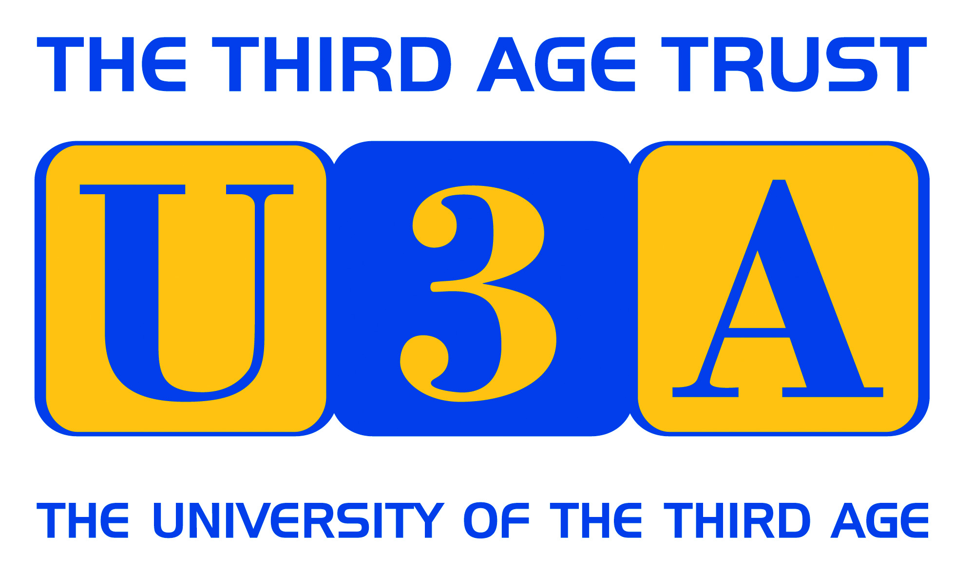 Cumbria U3A Network
Language groups Workshop
Monday 30th October. 10.00 – 3.30
Quaker Meeting House, Lancaster

Who is it for?
- Anyone who coordinates a language group or is considering doing so in the future.
- Anyone from a language group wishing to share good practice and discuss common problems.
What will you gain?
- A better understanding of best practice in running language groups
- Knowledge of learning techniques used successfully in other groups
- Knowledge of additional learning materials
- Problem solving e.g. moving on from ‘beginners’; mixed ability groups

OUTLINE PROGRAMME
10.00 onwards Refreshments and registration
10.20 Welcome and Introduction
10.30 Presentation from Sylvia Duffy, National Subject advisor
for French: ‘Moving your group forward’
11.00-12.30: Group sessions
1) Identifying and exploiting learning materials
2) Extending vocabulary and integrating grammar practice
3) Using the internet
12.30 Lunch – plenty of cafes and sandwich shops nearby or bring your own
1.30 - 3.00 Group sessions:
4) Mixed ability and leaderless groups
5) Topics for conversation practice
3.00 Refreshment break
3.15 Where do we go from here?
There will be no charge for this event.
Registration details and further information can be found on the NW website at
https://u3asites.org.uk/north-west/events
or by contacting John Eakins: jpe988@gmail.com or 015395 59365

