Speyside Trip Report

Sandbach U3A Birdwatching Group, Scotland, 9th - 14th May 2016

The long-awaited moment arrived for the Birdwatching Group’s most ambitious project yet. All over the district, folk were climbing into taxis, mounting bicycles or getting into relatives’ cars and heading for Crewe station. We met in the station entrance, and made our way down to Platform 11, there boarding the Glasgow train. After ejecting one or two usurpers of our pre-booked seats, and squeezing our week’s worth of baggage into inadequate daytrip-sized luggage spaces, we settled down for our journey. Just like home really, reading the paper or a book, listening to music, doing the crossword, watching a video on iPad or similar - I’m sure I saw a pair of knitting needles sticking out of a bag! For the drivers amongst us it was great to be able to watch the scenery go by rather than battling the traffic on the M6.

Glasgow arrived around lunchtime, and we raided the various sandwich emporia. Enough time to sit on the station and watch the world go by as we ate, while we kept an eye on the departures board. Soon enough the time for the Inverness train came round, and we clambered aboard. Luggage space was not quite so cramped, and again we settled in. Once through Scotland’s central belt, where a Sparrowhawk kept pace with the train for a short while, the scenery opened up, and pastimes disappeared in favour of more watching. We passed Gleneagles, Pitlochry and Blair Atholl, glimpsing the castle through the parkland. Newtonmore, Kingussie and Aviemore were brief stops before we were coasting to a halt at Carrbridge, our destination for our 5-day visit. Met by our mini-coach, we were quickly into our guest house accommodation, joining up with our advance party (bringing our number to 16) with dinner to follow not long after.

Our first day started very early, with movement around the guest house at 0430. The mini-coach left at 0500, and we were at Loch Garten at 0530. As we walked down to the hide we could hear a Cuckoo, and rounding a bend on the path, we saw an RSPB volunteer gesturing at us. We quickened our pace, and within a few seconds, were gazing at a turkey-sized Capercaillie, perched out in the open on the branch of a pinetree. Unusually the hide had few visitors, so the group was able to cycle through the two telescopes focussed on the bird several times over, all getting excellent views. We were able to set up one of our own scopes on the Caper, allowing even more opportunity to gaze in awe at this mighty grouse.

Capercaillie drawn by Carole Kynaston
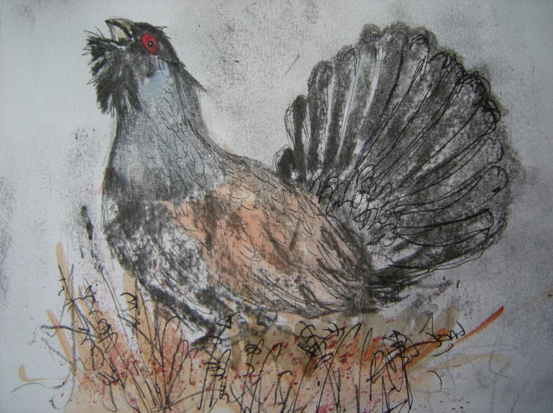

When a Caper is available to watch, attention is dragged away from the reserve’s raison d’etre. Yet an Osprey’s head could be seen in the nest, and we were soon also viewing the male Odin, who brought in a fish to a dead tree, and started to strip flesh off it, to the female’s obvious disgust (CCTV showed her berating him). Feeders at the hide gave us Siskin and Great Spotted Woodpecker, while a Chiffchaff sang in the car park, where we obtained brief glimpses of a Crossbill and a Green Woodpecker.

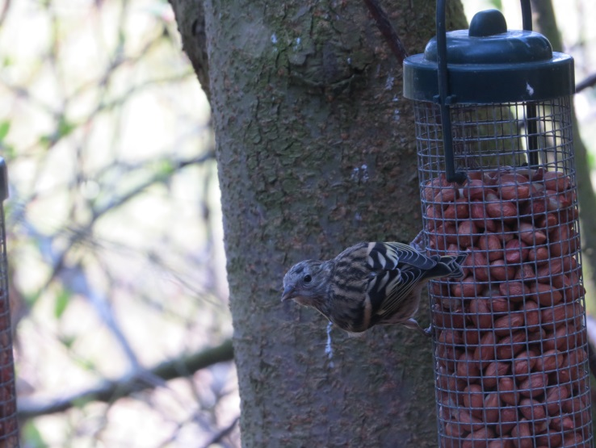
Siskin on Feeder at Loch Garten, photo Derrick Bradley

We returned to Carrbridge, and went up on to the moorland west of the A9. Here we picked up Meadow Pipit and Mistle Thrush, typical birds of this habitat, and a singing Whitethroat was culled from the scrub. Two fields over from our stance we started to see more unusual birds. Very quickly a pair of Red-legged Partridge, a summer-plumaged Golden Plover and a feeding Black Grouse, were identified. The Black Grouse sighting did away with the necessity of a second early start. It was an elated group which returned to Carrbridge for breakfast.

After demolishing a large breakfast, we stopped at flooded fields outside Boat of Garten. Among the wildfowl we saw the only Shoveler and Wigeon of the trip. At Loch Milton we admired the heronry while Willow Warblers sang their wistful song in the waterside alders. The walk through the woods to Loch Mallachie produced a female Goldeneye nursemaiding her seven youngsters. Loch Garten at lunchtime brought in Siskin and Long-tailed Tit, while two of our company connected with a red Crossbill. We connected too with members of our group, George & Jean, dropping into Garten from their own adventure trip to Orkney, and en route back to Sandbach.

After lunch we made our way to Dulnain Bridge, where the availability of sunshine and a wall to sit on slowed us down considerably. Here we watched as a pair of Dippers brought in food to their nest up a side burn, now arcing high over the riverside, now flashing through the culvert that brought the stream down to the river. Sand Martins were the predominate hirundines here, and our first Swift put in a brief appearance. But we had to wait some time before Grey Wagtail materialized out of the margins of the river, another near-certainty for this site. Our day finished early and we returned to Carrbridge.

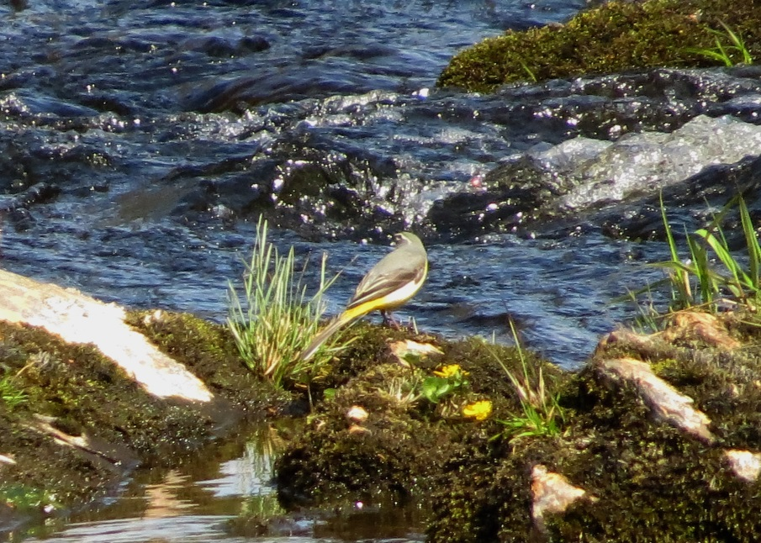
Grey Wagtail photo Derrick Bradley

Another favourite moment was sitting on the wall at Dulnain Bridge watching the Dippers and Grey Wagtails going about their daily lives. They gave us a good show.
Christine Roche.

Wednesday had us away early across prime moorland habitat in patchy low cloud. It wasn’t long before we were bringing the mini-coach to a halt several times to admire roadside Red Grouse, a number adopting their “Famous Grouse” pose.

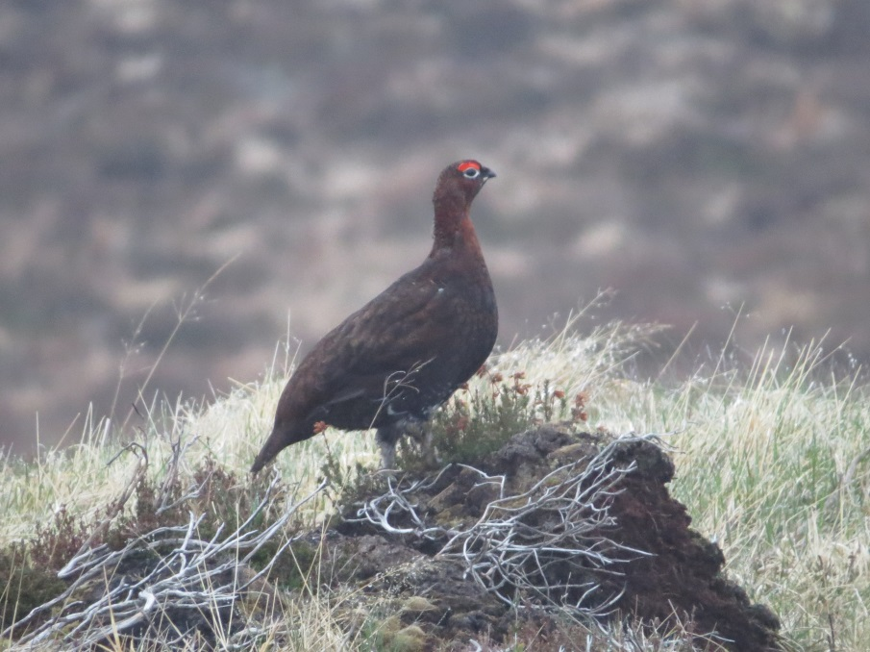
“Famous Grouse” photo Derrick Bradley

At Lochindorb, we were quickly on to the Black-throated Diver, difficult to pick out from the roadside against the heathery lochside in dull conditions. We were impressed with its ability to move fast both under and on the water as it made its way up the loch. Returning to the mini-coach we flushed a Snipe from pretty much under our feet, signalling the sighting of a number of its wader friends, with Curlew, Common Sandpiper, Redshank and Oystercatcher all filling lines in the notebook.

An Osprey was identified coming in from the west and we followed it as it hunted the water on the north side of the loch. We picked it up later further down the loch and saw it take a fish from the water, mobbed by Common Gulls, readjusting its catch fore and aft, struggling to gain height as it flew over the castle on its tiny island, and circling the woodland near the lodge. We left Lochindorb over moorland covered with nesting Common Gulls.

The best of the week was, for me, on Wednesday at Lochindorb when we saw the Osprey and for so long, following its movements, and then at the other end of the loch, again following the movements of the Osprey and seeing it dive and come up with a fish. Some birds come and go in a flash but this one gave a great performance. Christine Roche.

My memorable point of the holiday among so many was the surprise in the middle of the week while we were driving through grouse country with heather filled hillsides, and it was at first a litter problem, with loads of white paper bags blowing around. Then a voice on the coach said Common Gull. Suddenly the vision cleared and the grouseland at the side of the road was covered with Common Gulls on their nests. How the males knew where their females were is still one of today’s big mysteries. But to see so many gulls packed into one small area was worth it, especially when we sometimes struggle to find one on our monthly trips to the Wetlands. David Millington.

We drove up to the north Moray coast, and on the approach road to Roseisle Forest we saw our first Hooded Crow. The forest itself was very quiet, but there were Red-breasted Merganser close in off the beach, and bobbing up and down, and needing considerable patience to see through the ‘scope, 5 or so Eiders farther out. On then to the fishing village of Burghead where Gannet, Kittiwake, Fulmar, Guillemot and Shag passed by offshore. Rock Pipits were numerous around the harbour and Linnets flew into the gardens of fishermen’s cottages.

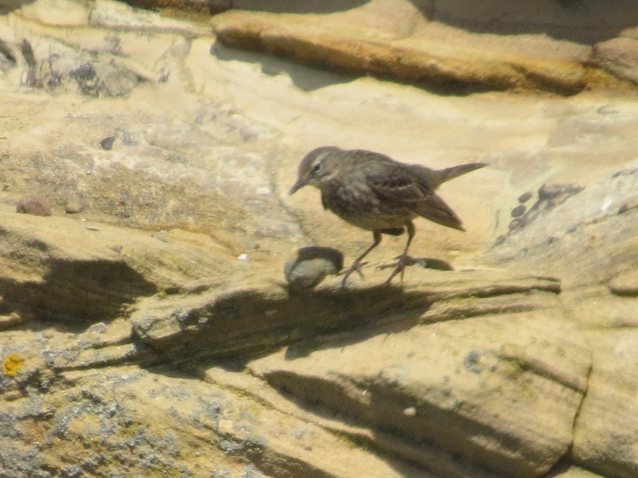
Rock Pipit photo Derrick Bradley

We managed to find the RSPB’s newest reserve, Loch Spynie, a little way inland, and noticed Yellowhammers in the field edges alongside farm tracks. Warblers were in evidence, and we added Garden Warbler and Chiffchaff here. From the hide we could see a couple of perched terns with quite dusky bodies on first sighting, which, on flying, resolved themselves into Arctic Terns, a bonus before we set off for Carrbridge. In the evening our digestif walk after our meal took us down to the River Dulnain, where we heard Cuckoo from the centre of the village and watched Dipper under the packhorse bridge.

Day 3 took us up Cairngorm, stopping first at Loch Morlich. Smaller birds were in evidence here and we added Spotted Flycatcher and Brambling to our list. Onwards to Coire Cas, where the Black Grouse lek had ceased, and only its cousin Red Grouse poked its head out of the heather. Nevertheless the spring sunshine lit up the mountainside, and reindeer could be picked out high above. At the lower funicular station we were treated to good views of Ring Ousel, and saw one the highest resident Dunnocks in the country.

Next stop was Inshriach Nurseries, where the picnic tables were put to good use. Many of us partook of a piece of the Cafe’s famous cakes, while almost nose to beak with the throng on the feeders. A female Siskin was literally inches away from the window feeding for some 20 minutes, while a Goldcrest paid a fleeting visit. We moved on to Loch Insh, finding the parking space taken up with canoeing paraphenalia. Dropped off by our mini-coach, we walked up the path to the Kincraig church for another nose to beak view, this time with an Osprey sitting on an island nest out in the loch.

And then to another RSPB reserve, the Insh Marshes. The overlook gave a great view of the marshes which at first glance seemed birdless. Further study proved fruitful, with Curlew, Greylag and Lapwing sightings. A pair of Canada were our first, chasing a pair of Ravens obviously too close to their nest, and which were also a trip first. The identification of a small duck resolutely displaying its grey back to us was put on hold until we found a better angle from another hide to identify a male Teal, with a female apparently on a nest. Back to Carrbridge then, where an after-dinner outing brought in a couple of Long-eared Owls, along with calling Cuckoo and another Snipe. Thanks to drivers Jane and Kath, who made our evening excursion possible.

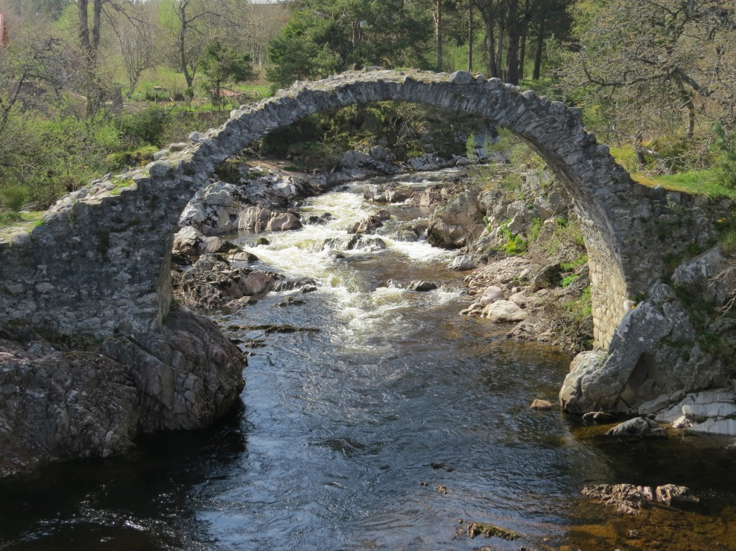
The Carrbridge photo Derrick Bradley

And so to our last birding day. The first heavily overcast day brought a cold easterly wind to blow us into the Findhorn Valley. In spite of that our first stop at Findhorn Bridge proved worthwhile. Here we encountered our fourth Dipper of the trip, while all three common hirundines put in an appearance. Four Common Terns were patrolling the rapids while the first Kestrel of the trip hovered nearby. And then a male Mandarin was discovered in one of the side burns, feeding busily, its extravagantly-coloured plumage in vivid contrast to the hues of a highland hillside. Red-legged Partridges, apparently common in the valley, also showed off their own colourful tints in brilliant light when the sun broke through later.

Our walk up the valley was made in cold conditions, with very little to show for our efforts other than the spectacle of two feral goats locking horns on a near-vertical hillside. Back at the Bridge we came across a pair of Goosander in the fast-flowing water, and at least a couple of Spotted Flycatchers on fence wires. We set off up the Farr Road with the sun at last showing through, catching sight of several Red Grouse on the way. At a small plantation just over the ridge line a period of patient watching eventually brought in a Tree Pipit as it parachuted down into a hawthorn tree.

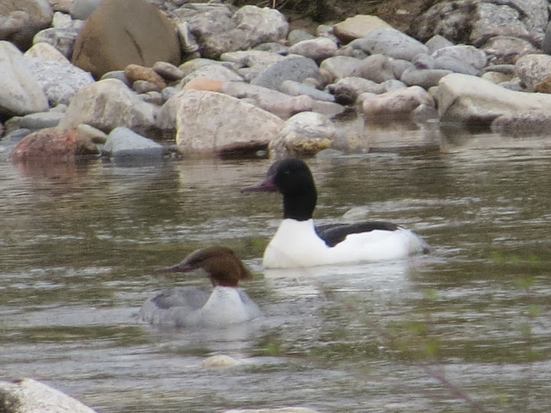
Goosander photo Derrick Bradley

RSPB Loch Ruthven was our last reserve, famed for its breeding Slavonian Grebes. Sure enough we saw at least five, some at distance, some close to, sporting their yellow fright wigs. Little Grebes with chicks were also observed, as were both Buzzard and our fifth Osprey. Common Sandpipers were criss-crossing the loch with their flickering flight pattern, and a large raptor dropped out of a tree onto a small peninsula some distance away. Before scopes could be focussed, it was up and away in a flurry of dark tawny with paler thighs, a brief glimpse of a Golden Eagle. Last stop was at Flichity, where we had organised carrot cake and coffee, and use of the facilities. We had good views of Song Thrush here together with Blue Tit, Goldfinch and Bullfinch, and Buzzard thermalling off a cliff face.

Seeing the Slavonian Grebes on Loch Ruthven was also special, and the Little Grebe busily feeding her young. Christine Roche.

And sadly we reached the end of our time in Speyside. An early breakfast on Saturday morning and then we were waiting at Carrbridge Station for the Glasgow train, while Greylag and Raven saluted our departure. Another lunch break at Glasgow Queen Street and it was just one stop to Carlisle, where we abandoned the rail network to its weekend maintenance chaos, and took to a coach to run us down the M6 to Sandbach. When the planning for this expedition started in February 2015, members were asked if they would like to see Capercaillie, Crested Tit, Golden Eagle, Black Grouse, Black-throated Diver, Scottish Crossbills, fishing Ospreys and summer-plumaged Slavonian Grebe. Only Crested Tit from that list escaped our optics, although views of Eagle and Crossbill were pretty limited. Still it certainly leaves us targets for next time, despite a field trip total of some 102 species!

Richard Howells (with editing by John Adams)

Speyside Trip List: 9th-14th May 2016

Species | Dates | Locations
Mute Swan | 11 | Loch Spynie
Greylag Goose | 9, 10, 11, 12, 14 | BA, DH, BG, LMa, IM, CB
Canada Goose | 12 | Insh Marshes
Mandarin | 13 | Findhorn Bridge
Wigeon | 10, 11 | Boat of Garten, Loch Spynie
Teal | 10, 12 | Boat of Garten, Milton Loch, Insh Marshes
Mallard | 10, 11, 12, 13 | DH, ML, LD, LMo, IM, FV
Shoveler | 10 | Boat of Garten
Tufted Duck | 10, 11 | Boat of Garten, Loch Garten, Loch Spynie
Eider | 11 | Roseisle
Goldeneye | 10, 11, 12 | BG, LG, LMa, DB, LS, LMo, KC
Red-breasted Merganser | 11 | Roseisle
Goosander | 10, 12, 13 | Carrbridge, Findhorn Bridge
Red Grouse | 11,12, 13 | Lochindorb, Coire Cas, Farr Road
Black Grouse | 10 | Dalnahaltnach
Capercaillie | 10 | Loch Garten
Red-legged Partridge | 10, 13 | Dalnahaltnach, Findhorn Valley
Grey Partridge | 11 | Moray
Pheasant | 9, 10, 11,12,13 | Newtonmore, Forres, Loch Spynie, IM, FV
Black-throated Diver | 11 | Lochindorb
Little Grebe | 10,11,13 | Boat of Garten, Loch Spynie, Loch Ruthven
Slavonian Grebe | 13 | Loch Ruthven
Fulmar | 11 | Off Burghead
Gannet | 11 | Off Burghead
Cormorant | 11 | Burghead, Roseisle
Shag | 11 | Off Burghead
Grey Heron | 9, 10, 11, 12 | Newtonmore, Milton Loch, Loch Spynie, KC, IM,
Sparrowhawk | 9 | Bargeddie
Buzzard | 9, 10, 11, 13 | Struan, DB, Loch Spynie, Loch Ruthven, Flichity
Golden Eagle | 13 | Loch Ruthven
Osprey | 10, 11, 12, 13 | Loch Garten(2), LD, Kincraig, Loch Ruthven
Kestrel | 13 | Findhorn Bridge
Moorhen | 10, 11, 13 | Boat of Garten, Milton Loch
Coot | 11 | Loch Spynie
Oystercatcher | 10, 11, 12, 13 | Perth, Dalnahaltnach, LD, Insh Marshes, FV
Golden Plover | 10 | Dalnahaltnach
Lapwing | 9, 10, 11, 12, 13 | Perth, BG, Dalnahaltnach, Insh Marshes, FV
Snipe | 10, 11, 13 | Dalnahaltnach, Lochindorb, Findhorn Valley
Curlew | 10, 11, 12, 13 | Dalnahaltnach, Lochindorb, Cromdale, IM, FV
Common Sandpiper | 10, 11, 13 | Loch Mallachie, Loch Garten, LD, FV, Loch Ruthven
Redshank | 10, 11, 12 | Boat of Garten, Lochindorb, Insh Marshes
Kittiwake | 11 | Off Burghead
Black-headed Gull | 9, 11, 12, 13 | Perth, Lochindorb, Loch Spynie, Loch Morlich, IM
Common Gull | 9, 10, 13 | Dalnahaltnach, Boat of Garten, FV, Loch Ruthven
Lesser Black-backed Gull | 9 | Kirkwood
Herring Gull | 9, 10, 11 | Perth, Dalnahaltnach, Roseisle
Great Black-backed Gull | 11 | Burghead
Common Tern | 13 | Findhorn Bridge (4)
Arctic Tern | 11 | Loch Spynie (2)
Guillemot | 11 | Off Burghead
Rock Pigeon | 11 | Burghead
Stock Dove | 11, 13 | Loch Spynie, Loch Ruthven
Wood-Pigeon | 9, 10, 12, 13 | Newtonmore, Loch Garten, Dalnahaltnach, CB
Collared Dove | 10, 11, 12, 13 | Carrbridge
Cuckoo | 10, 11, 12, 13 | Loch Garten, CB, LD, Loch Ruthven (in flight)
Long-eared Owl | 12 | Dalnahaltnach
Common Swift | 9, 11, 12, 13 | Larbert, Dulnain Bridge, Kinloss, Insh Marshes, CB
Green Woodpecker | 10 | Loch Garten
Great Spotted Woodpecker | 9, 10, 12 | Carrbridge, Loch Garten, Inshriach
Sand-Martin | 10, 11, 13 | Dulnain Bridge, Loch Spynie, FV, Loch Ruthven
Swallow | 9, 10, 12, 13 | Bargeddie, DH, Carrbridge, Coire Cas, FV
House Martin | 9, 11, 13 | Larbert, Lochindorb, Findhorn Valley
Tree Pipit | 13 | Farr Road
Meadow Pipit | 10, 11, 12, 13 | Dalnahaltnach, LD, Coire Cas, Cairngorm, FV
Rock Pipit | 11 | Burghead
Grey Wagtail | 10, 13 | Dulnain Bridge, Findhorn Bridge
Pied Wagtail | 10, 11, 12, 13 | BG, Roseisle, Burghead, Coire Cas, Cairngorm, FV
Dipper | 10, 11, 13 | Dulnain Bridge (2), Carrbridge, Findhorn Valley
Wren | 10, 11 | Carrbridge, Loch Spynie
Dunnock | 10, 11, 12, 13 | Dalnahaltnach, Cairngorm, Inshriach, FV
Robin | 10, 11, 12, 13 | Dalnahaltnach, Carrbridge, LMo, Inshriach, LS
Ring Ouzel | 12 | Cairngorm (2)
Blackbird | 10, 12, 13 | Dalnahaltnach, Carrbridge, Kincraig, IM, FV
Song Thrush | 10, 11, 13 | Loch Garten, Carrbridge, Flichity
Mistle Thrush | 10, 11, 12, 13 | Dalnahaltnach, Carrbridge, LD, Cromdale, FV
Garden Warbler | 11 | Loch Spynie
Whitethroat | 10 | Dalnahaltnach
Chiffchaff | 10, 11, 12, 13 | LG, Carrbridge, LS, Findhorn Valley, Loch Ruthven
Willow Warbler | 10, 11, 12,13,14 | DH, CB, LG, ML, LS, CC, CG, IS, KC, IM, LR.
Goldcrest | 12 | Inshriach
Spotted Flycatcher | 12, 13 | Loch Morlich, Findhorn Bridge
Long-tailed-Tit | 10, 11 | Loch Garten, Loch Spynie
Blue Tit | 10, 12, 13, 14 | Loch Garten, Inshriach, Insh Marshes, Carrbridge
Great Tit | 10, 11, 12 | Loch Garten, Loch Spynie, Inshriach, Insh Marshes
Coal Tit | 10, 11, 12, 13 | CB, ML, LG, LMa, LD, LMo, IS, IM
Magpie | 10, 11 | Dalnahaltnach, Loch Spynie
Jackdaw | 10, 11, 12,13,14 | Dalnahaltnach, CB, LD, IM, FV, Carrbridge
Rook | 10, 11 | Milton Loch, Forres
Carrion Crow | 11, 12 | Kinloss, Insh Marshes
Hooded Crow | 11 | Roseisle
Raven | 12, 14 | Insh Marshes, Carrbridge Station
Starling | 10, 11, 12, 13 | Carrbridge, Burghead
House Sparrow | 10, 11, 12, 13 | Carrbridge, Burghead
Chaffinch | 10, 11, 12, 13 | CB, ML, LG, LD, LMo, KC, IS, FV, LR
Brambling | 10 | Loch Morlich
Greenfinch | 10, 11, 12, 13 | Carrbridge, Lochindorb, Inshriach
Goldfinch | 10, 11, 12, 13 | Carrbridge, Burghead, Lmo, Kincraig, Flichity
Siskin | 10, 12, 13 | Carrbridge, LMa, LG, Loch Morlich, Inshriach
Linnet | 11 | Burghead
Crossbill sp. | 10 | Loch Garten
Bullfinch | 13 | Flichity
Yellowhammer | 11 | Loch Spynie

BA Blair Atholl
BG Boat of Garten
CB Carrbridge
CC Coire Cas
DB Dulnain Bridge
DH Dalnahaltnach
FV Findhorn Valley
IM Insh Marshes
IS Inshriach
KC Kincraig
LD Lochindorb
LG Loch Garten
Lma Loch Mallachie
Lmo Loch Morlich
LS Loch Spynie
ML Milton Loch

